Press release
Global Flight
Ravindra Bhagwanani, CEO and Chairman
ravindra@globalflight.net
LOYALTY & AWARDS 2021

SUMMARY

1. CONFERENCE PRESENTATION 2
2. GLOBAL FLIGHT PRESENTATION 3
3. TEAM & CONTACTS 4
4. LOGOS 5

- CONFERENCE PRESENTATION

Loyalty & Awards 2021 demonstrates the benefits of 100% in-person events

Plaisance du Touch, 07 September 2021 - The upcoming Loyalty & Awards 2021 conference in Dubai will be held as 100% live event. The conference organiser Global Flight is confident about a quick rebound of the travel market once travel restrictions are removed and calls for other governments to follow UAE's move to open up the market.

The UAE's recent announcement to open up the country completely by removing any remaining entry restrictions confirms Global Flight's early strategy to position Loyalty & Awards 2021, to take place from 11-13 October at the brand-new Sofitel The Obelisk in Dubai, as 100% live event. It will indeed be one of the first major industry events without any hybrid concept.

"While we may lose a tiny share of delegates with this approach as well as delegates from closed countries such as Australia, the overwhelming majority welcomes our approach", Ravindra Bhagwanani, Managing Director of Global Flight, explains. "At the end of the day, would we as an industry living from the mobility of people be credible if we were not willing to resume travel ourselves?" he questions rhetorically.

Dubai and the UAE also demonstrate the positive impact on travel when restrictions are lifted. Right after lifting the restrictions, Emirates announced a massive increase of capacity on its flights, notably to Europe. While Dubai's main motivation to open up is directly related to the Expo 2020 starting on 01 October, events like Loyalty & Awards clearly benefit of such policy as well. "Other governments rather have a close look at what's happening in Dubai if they want to avoid a permanent shift of market shares due to their hesitation to remove restrictions", Bhagwanani warns.

The event will feature its traditional successful mix of an interesting agenda, unparalleled networking opportunities and the integration of the Golden Loyalty Awards, the leading recognition in the travel loyalty industry judged by loyalty professionals.

The event is expected to host 200+ delegates from all over the world. At this point, it actually records more advance bookings than ever at the same point, underlining the hunger of the industry for live events. Current registrations are a representative snapshot across the industry, embracing companies from Japan Airlines to Volotea and from Hawaiian Airlines to Jumeirah Hotels. Emirates and Accor are the official travel partners of the event.

For further information, please visit the conference website: http://www.loyalty-and-awards.com.

Place and venue for 2021
Dubai, United Arab Emirates.
Easy international access via Dubai International Airport.

Venue: Sofitel The Obelisk
Wafi - Sheikh Rashid Rd - Umm Hurair 2 - Dubai – UAE
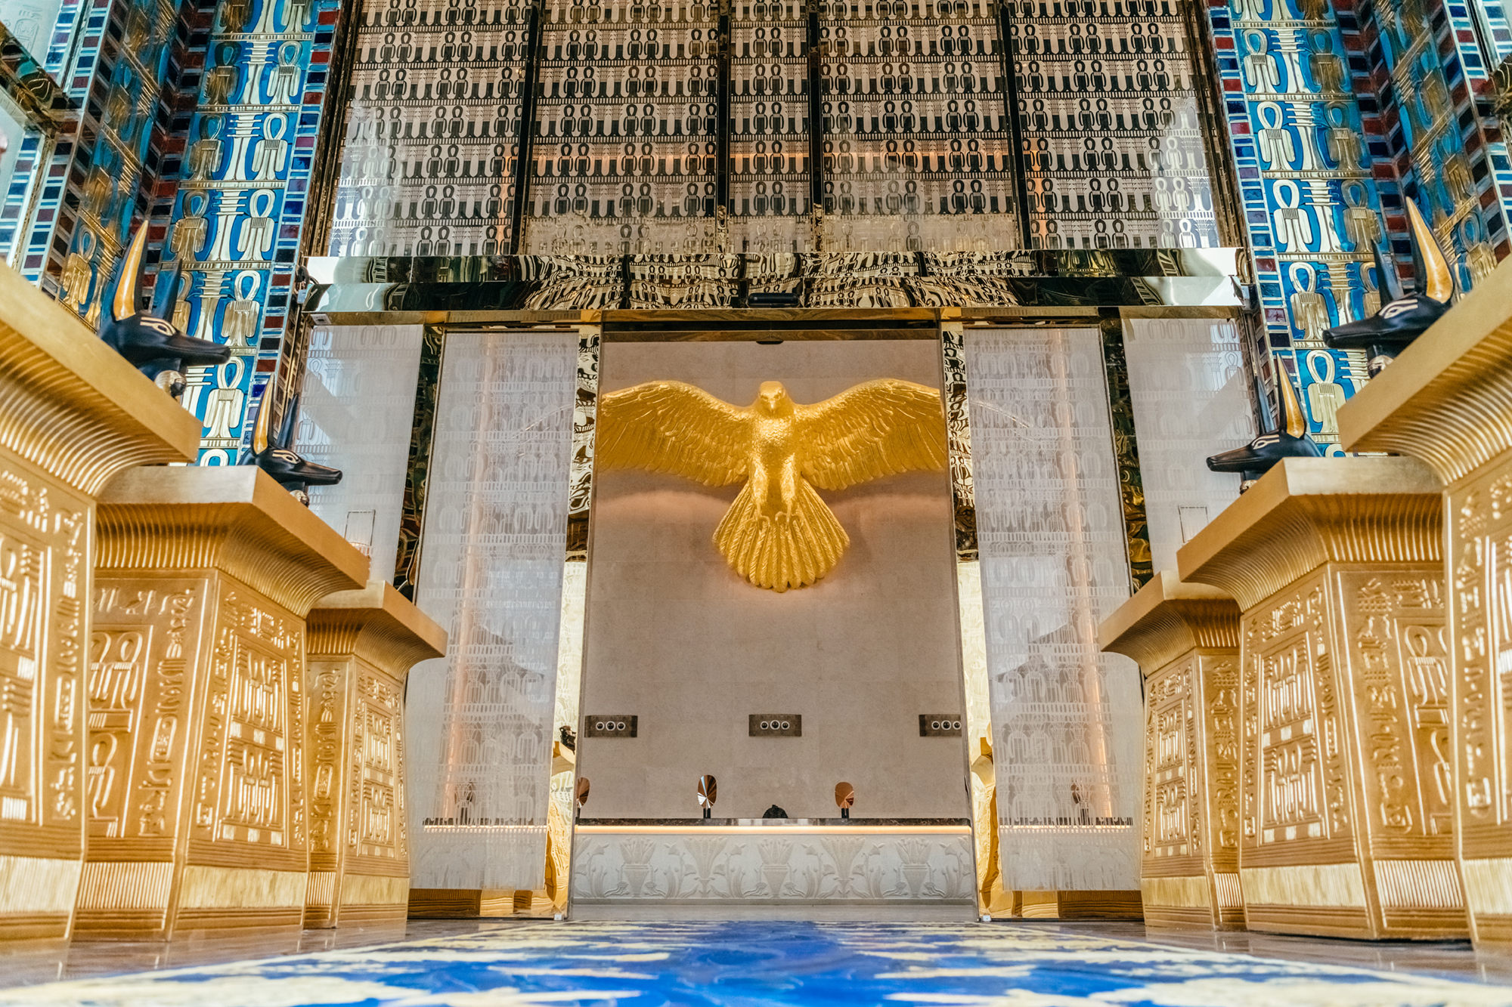

- GLOBAL FLIGHT PRESENTATION

Global Flight, founded in 1996 and based near Toulouse/France, is a leading independent management company focussing exclusively on the complex topic of customer loyalty and loyalty programs in the travel industry.
Next to a wide range of management-related services for program operators - including the organisation of the annual Loyalty & Awards conference -, Global Flight also offers leading services to frequent flyers and corporations in the area of loyalty programs, allowing them to understand both the user and operator side of the business.
Constantly monitoring all 220+ Frequent Flyer Programs and hundreds of other travel loyalty programs, Global Flight has an incomparable knowledge and expertise, proven by a track record of 25 very successful years working with more than 50 different companies from the travel loyalty industry.

Further details here: http://www.globalflight.net/about-us/what-we-do/

- TEAM & CONTACTS

- Ravindra Bhagwanani, Managing Director of Global Flight and Chairman of the Loyalty & Awards Conference
ravindra@globalflight.net - +33-5-61-71-16-57 (French time)
For any questions regarding the content of the conference or any complaints.

- Rémi Bourdoncle, Marketing & Communication Assistant
remi@globalflight.net - +33-6-12-52-79-08 (French time)
For any marketing & communication related questions.

- Mark Dority, Director of Sales
mark@globalflight.net - +1-303-359-5805 (USA time)
For any questions about sponsorships.

- Antoine Gaultier, Sales Assistant
antoine@loyalty-and-awards.com - +33-6-01-71-96-02 (French time)
Sales representation – Event promotion

- Justine Massip, Marketing and Event manager
justine@globalflight.net - +33-6-88-16-29-34 (French time)
All operational, logistical and marketing & communication related questions. She can help delegate during the registration or for the payment.

For further Media information, please contact:

Global Flight SARL
4 Impasse du Petit Castet F31830 Plaisance du Touch, France
Phone : +33-5-61-71-16-57
E-mail : info@globalflight.net
Internet : www.loyalty-and-awards.com & www.globalflight.net

- LOGOS

